Formation of ACMA

Anglican Communion of Minority Affairs–(ACMA) was promoted by the Anglican Church of India (ACI) which is associated with the BDTA and CEEC. Anglicans re-established the Anglican Church of India on August 24th, 1964. The Synod of the Anglican Church of India constitutes of all the Diocesan Bishops, Clergy Secretaries, Lay Leaders of the Dioceses and Church related organizations and representatives of each Dioceses and Independent Churches.

The Anglican Church of India is mainly involved in the establishment of the churches and assisting the churches which are affiliated and in strengthening the churches and its pastors and evangelists at all levels. Since the ministerial work is immense the other aspects of socio-economic works could not be mingled and the allocation of time and responsibilities is a real challenge.

The ACI is involved both in carrying out the religious and social service activities. In order to do justice to both the services, the programs were planned in a wider level and it was decided to have a separate entity to carry out the activities with different dimension involving all the linguistic minorities. Since ACI believes in holistic development and formed ACMA to work for the cause of the minorities and link with the Ministry of Minority Affairs and enabling the poor and needy to avail the welfare schemes towards economic stability of the minorities. A team of members under the Leadership Bishop.Dr.A.John Sathiya Kumar was organised and ACMA has representation from Muslim and Jain at present on the Board of members.
Aim and objectives

The desire of the Founders is to establish an organisation for the Socio - Economic development of the notified minority communities which include Muslims, Christians (all denominations and ecumenical in nature), Sikhs, Buddhists, Parsis and Jains as per the National Commission for Minorities act 1992. The organisation is formed to formulate comprehensive strategy, policies and programs for the welfare and development of minorities.

Objects for which the organisation is established are:

- To carry out multi-pronged strategy for the development of Minority communities with focus on educational, economic development and strengthening of minority Institutions etc.

- To approach the Ministry for the Minority affairs and mobilize the schemes and implement the schemes by forming National level, State level, Zonal level and District level administrations towards accomplishing the programs.

- to ensure a more focused approach towards the issues relating to Minorities and facilitate the formulation of overall policy and planning, coordination, evaluation and the review of the regulatory framework and development programs for the benefit of the minority communities
- To disseminate information about these programs supported by the Ministry of minority affairs among the masses.

- To make known of all schemes/ programs which shall be an effective tool to bridge the gap of information between the Government and the people, particularly Minority communities,

- To ensure flow of information about the welfare and development programs/schemes from the ministry to the ground level for good governance.

- To provide for the delivery and holding of lectures, public meetings, classes, and conferences to advance the cause of the minorities.

- To grant fellowship, scholarship or other monetary assistance on such terms and conditions as may be prescribed, to such persons as it may select for carrying on research, investigation, or study in the development of the minorities and grant Quality Standard certificates, recognitions, degrees, doctorates and awards on all subjects and fields of research, development, education

- To recommend to the ministry of Minority Affairs through proper channels and make suitable grants of moneys or other assistance, to an University, educational institutions, libraries or other Societies for the conducting or the prosecution of any research or investigation or study in a subject in which the Organisation is interested and/or to get affiliated with other Universities as well as providing affiliation to other Colleges, Schools, Seminaries and other Institutions

- To grant relief and assistance to the needy victims during natural calamities such as famine, earthquake, and flood fire, pestilence, Tsunami etc. and to give donations and assistance to institutions, or persons engaged in such relief work.

- To setup and engage in Satellite Projects, TV Channels and Broadcasting and Telecasting for furthering the development of the minorities.
Strategy of ACMA

The concept of social development of the people is given higher importance and thus the churches are able to reach out the people and to care for their needs along with the spiritual inputs being given to them. The free cardiac screening camp was organised by one of our affiliated church and most of the affiliated churches are involved in such activities

The churches of the dioceses play Good Samaritan Role with compassion to deeply care about the people who are suffering the consequences of major natural calamities. Give priority to the children, the poor and the powerless. Some of our churches are involved in running the orphanages for the poor children and their total care is being extended. Child and youth care is aimed to discipline the children and the youth in a systematic way to reach the children and the youth as they need to be well covered at this stage so that when they grow they shall become a greater pillar to the society and the community at large.
Service projects

The Diocese and the pastors had taken up special drive activities during tsunami and the real love of God was exhibited to the victims of tsunami. Most of the member Churches are giving preferences for the social service activities as we believe in the holistic development of the human kind without any barriers of caste, creed, religion or sex. The special programs such as:

- women development,
- Youth leadership Training program,
- Environmental Awareness program,
- Vocational Training in various trades/ courses
- Medical/ Health Camps Program,
- Training in Modern Agriculture,
- Child Development Program,
- Rehabilitation of the physically Challenged
- Rehabilitation Street Children program
- Care and support to orphan, semi-orphans
Minority’s development

The Anglican Church has a policy to cater to the needs of any person from any community, caste, religion and especially it has great concern to serve the most deprived and neglected from the minority religion without any barriers of caste, creed, religion and sex. Thus the role of the Anglican has great impacts and also we have established good rapport with the community leaders to strengthen the socio-economic development of the poor and needy.

NEEDS/support request of ACMA

Right Support for Right purpose

ACMA is in need of valuable suggestions and financial supports to realize the cause of the minorities and your decision at this moment shall enable a part in establishing the social and economic development of the Minorities. Hope you would be creating a history in the soil of India

Your willingness shall bring a new era in the lives of the deprived
Name ……………………………………………………………
Address……………………………………………………………
……………………………………………………………
……………………………………………………………
Phone……………………………………………………………
E-mail……………………………………………………………

You are most welcome to visit our people and supports could be extended.

Anglican Communion for Miniority Affairs
(ACMA)
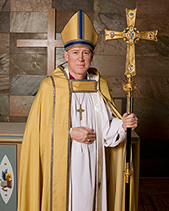
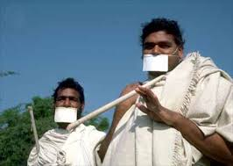


ACMA

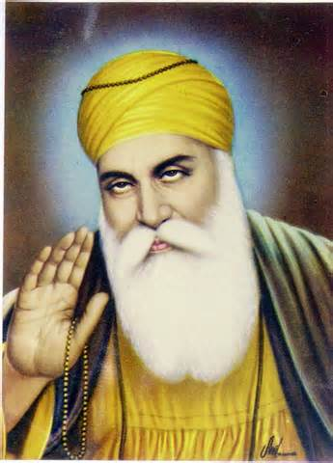




Reach us at:

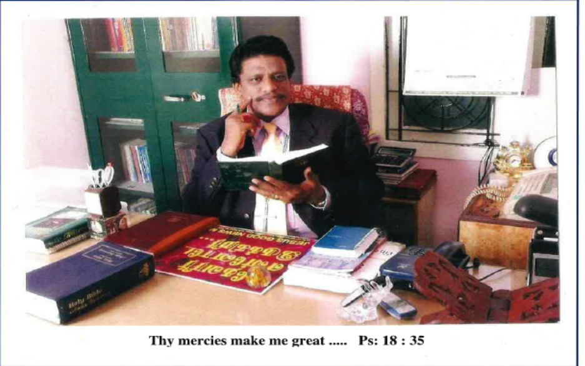

Bishop Dr.A.John Sathiya Kumar
Deputy Moderator, Anglican Church of India
National chairman, ACMA

